Game Meat / Viande de gibier
Wild Boar / Sanglier
Sausage Sticks / Bàtonnets de saucissons

Ingredients: Domestic Wild boar, Pork, Beef, Spices, Sea salt, Cane sugar, Cultured celery powder, Rice Flour, Starter culture, Olive oil, Natural wood smoke.
Ingredients: Sanglier domestique, Porc, Bœuf, Epices, Sel de mer, Sucre de canne, Poudre de céleri de culture, Farine de riz, Culture starter, Huile d’olive, Fumée de bois naturel.

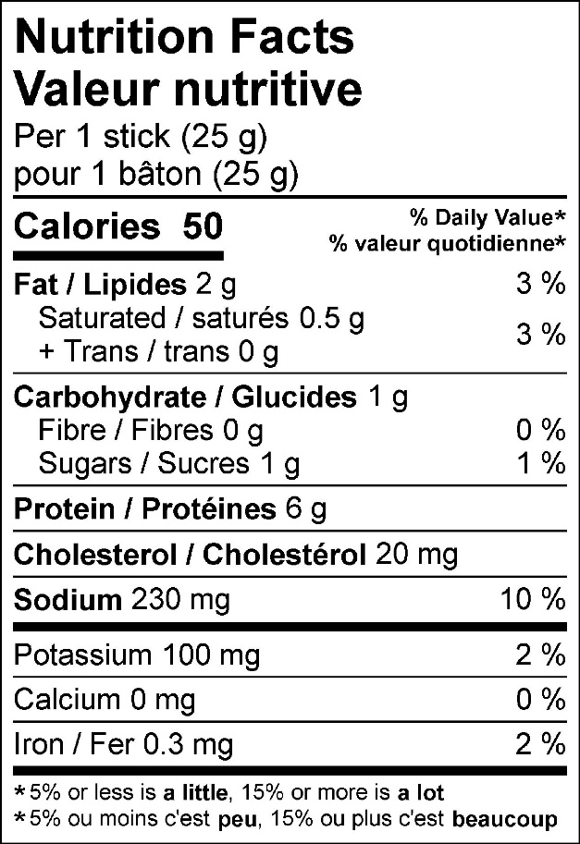

50 g (2-pack) 125 g (5-pack)
